- To Install Linux VM, Configure GCC, Setup Git Repository, Create Project Structure, Understand Shell Architecture, Build Initial Makefile.

Task -1: Create Project Structure as follows:

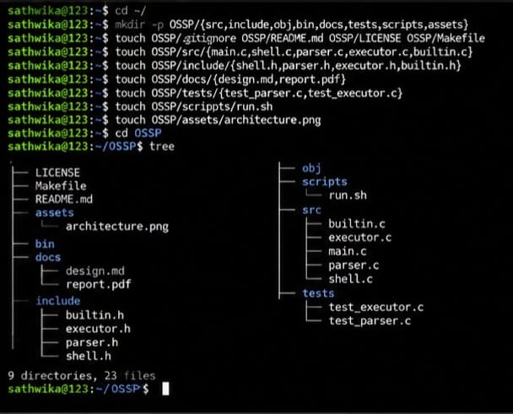

- To Analyze process abstraction, execute fork(), understand exec() family, analyze parent-child relationships, inspect process tree, practice system call tracing.

Task-1: Using a manual command understand the fork() and exec() system calls
Task-2: Write a C program to create a new process and accepting the user commands using lls. 